Combining Queries:

Problem
Refer the Schema Diagram for College Management System.
IMPORTANT NOTE:
ALL TABLE NAME STARTS WITH THE CAPITAL LETTER
Write queries for the displaying the following information.

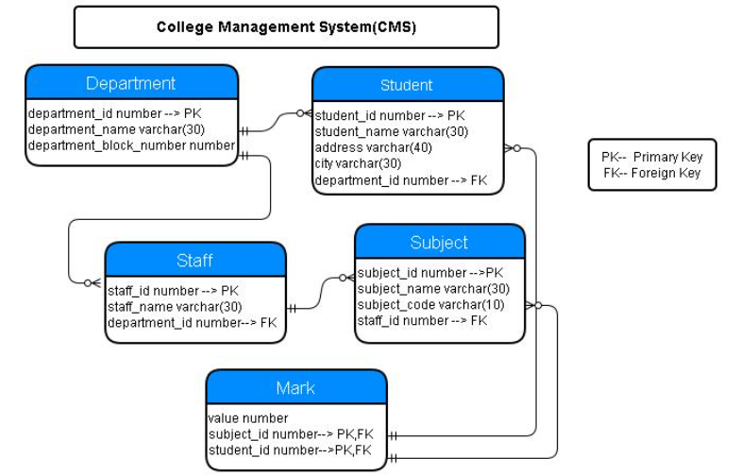

Q 1. Display the department details with respective staff details where department name starts with 'I'. (Use Natural Join).
Ans :
SELECT * FROM Department d NATURAL JOIN Staff s WHERE d.department_name like 'I%';

Q 2. Display the department name ,staff name by cross joining with staff.
Ans :
SELECT d.department_name, s.staff_name FROM Department d CROSS JOIN Staff s;

Q 3. Write a query to display all the 'bills' with 'meter' details. Display the records in ascending order based on meter number.
Ans :
SELECT * FROM bill b JOIN meter m ON b.meter_id = m.id ORDER BY meter_number;

Q 4. Write a query to display the details of the buildings whose owner name is Nicholas and 'Muzzammil'. Display the records sorted in ascending order based on the owner name.
Ans :
SELECT * FROM building WHERE owner_name IN ('Nicholas','Muzzammil') ORDER BY owner_name;

Q 5. Write a query to display the meter_id,due_date, total_units and payable_amount for the bills whose meter number contains a number '2' and for the bills whose meter number contains a number '9'. Display only the common records in descending order based on payable_amount.
Ans :
SELECT b.meter_id, b.due_date, b.total_units, b.payable_amount FROM bill b JOIN meter m ON m.id = b.meter_id WHERE meter_number LIKE '%2%' AND meter_number LIKE '%9%' ORDER BY b.payable_amount DESC;

Additional :

Problem
Refere the schema and solve the following Query requirements

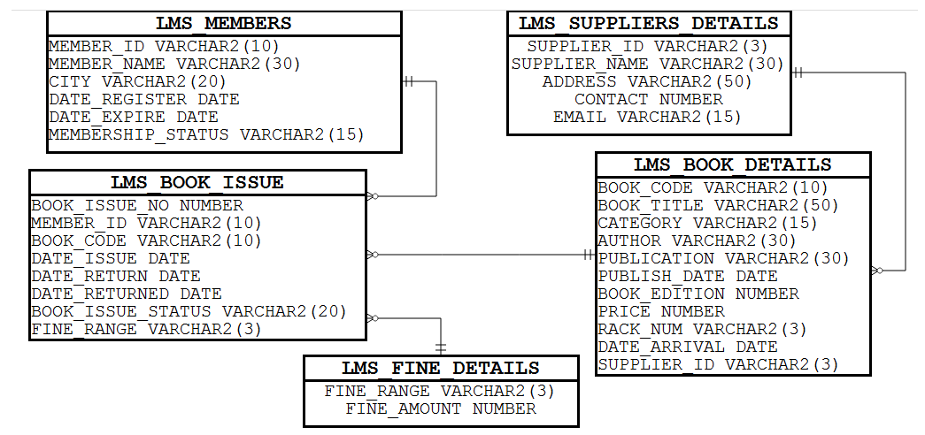

Q 1. Write a query to display the supplier_id that are in the lms_suppliers_details and not in the lms_book_details table. (Note: Use set operator.)
Ans :
SELECT supplier_id FROM lms_suppliers_details
MINUS
SELECT supplier_id FROM lms_book_details;

Assess :

Problem
Metro_Station(Set Operator)-Oracle-iLearn

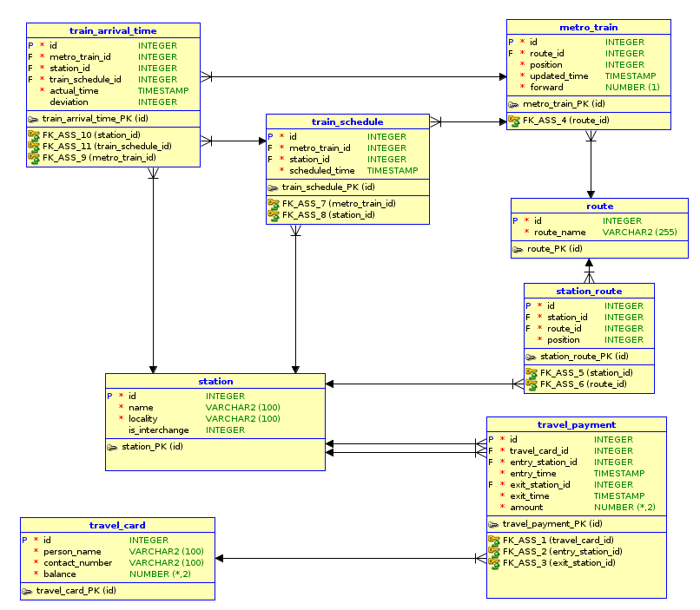

Q 1. Write a query to display all the travel payment details of the person whose name is 'Han Sai Por' and 'Michael'.
Ans :
SELECT t.id, t.travel_card_id, t.entry_station_id, t.entry_time, t.exit_station_id, t.exit_time,t.amount
FROM travel_payment t
JOIN travel_card tc
ON t.travel_card_id = tc.id
WHERE person_name IN ('Han Sai Por','Michael');

Q 2. Write a query to display all the route details along with travel payment details. Display the records in ascending order based on route_name.
Ans :
SELECT R.ID, R.ROUTE_NAME, T.ID, T.TRAVEL_CARD_ID, T.ENTRY_STATION_ID, T.ENTRY_TIME, T.EXIT_STATION_ID, T.EXIT_TIME, T.AMOUNT
FROM TRAVEL_PAYMENT T JOIN STATION S
ON T.ENTRY_STATION_ID = S.ID
JOIN STATION_ROUTE S1
ON S1.STATION_ID = S.ID
JOIN ROUTE R
ON S1.ROUTE_ID = R.ID
ORDER BY R.ROUTE_NAME;

